**STOCK MARKET CHART**

**NAME : NAVEDHA V**

**EMPLOYEE ID : 760850**

**(MIDDLEWARE BATCH 2)**

**SCREENSHOTS**

1. **Fetch Company**

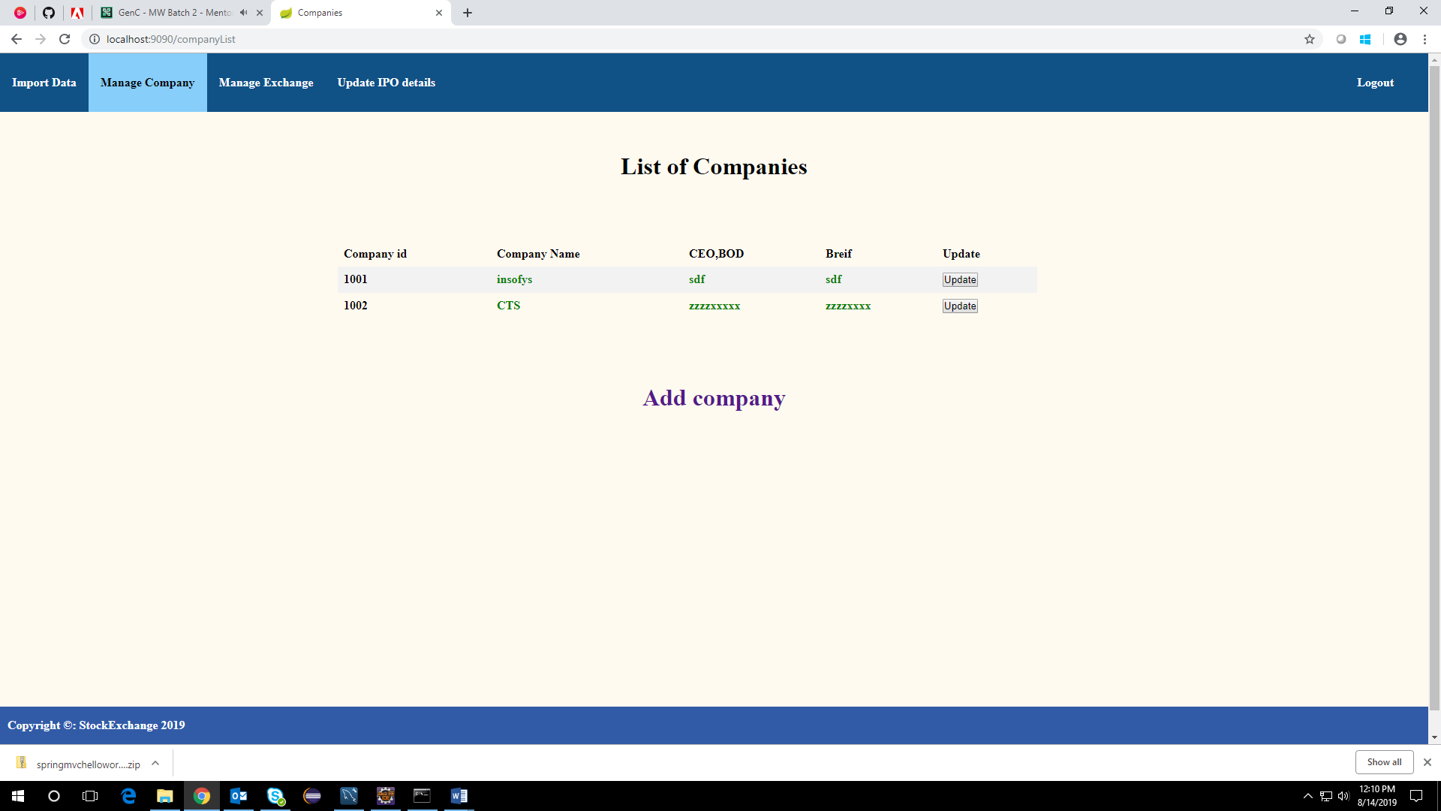

1. **Insert Company Page**

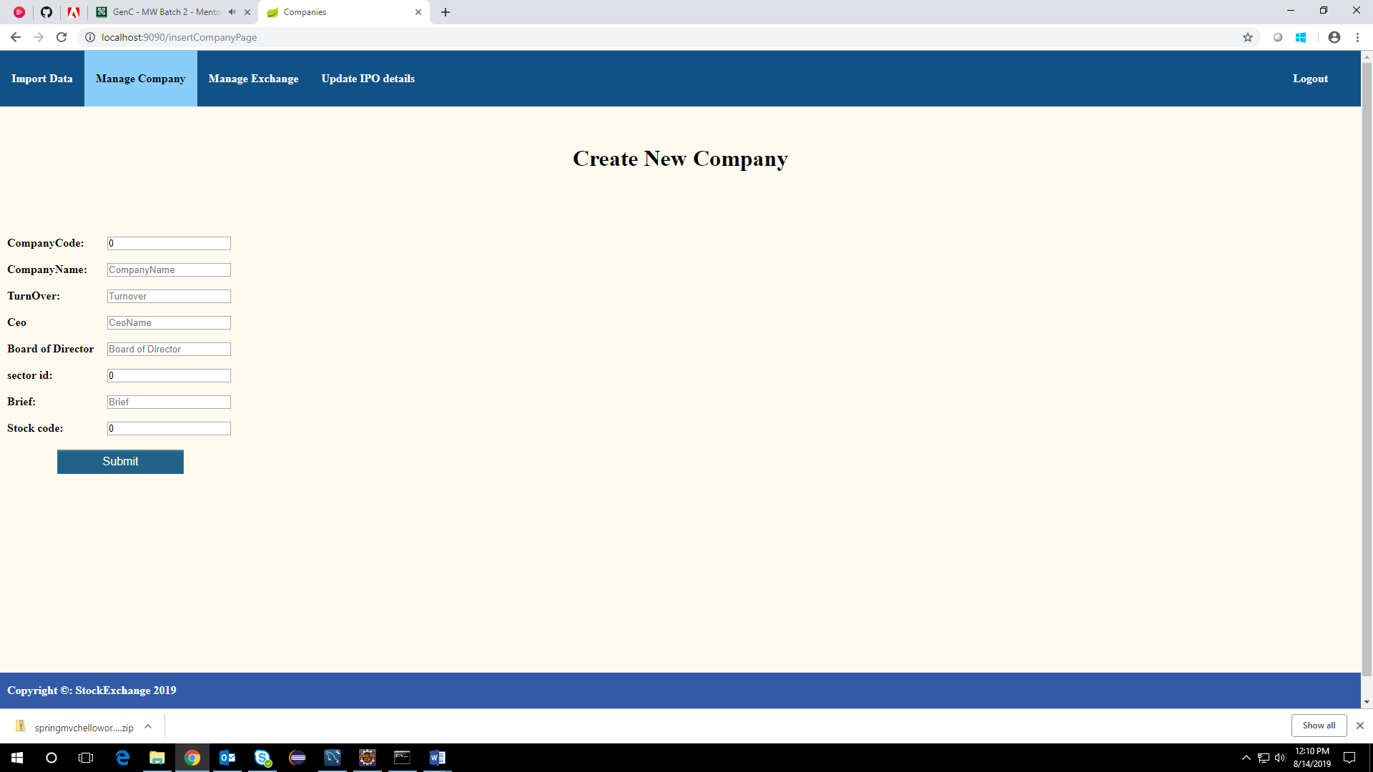

1. **After entering the data into the form**

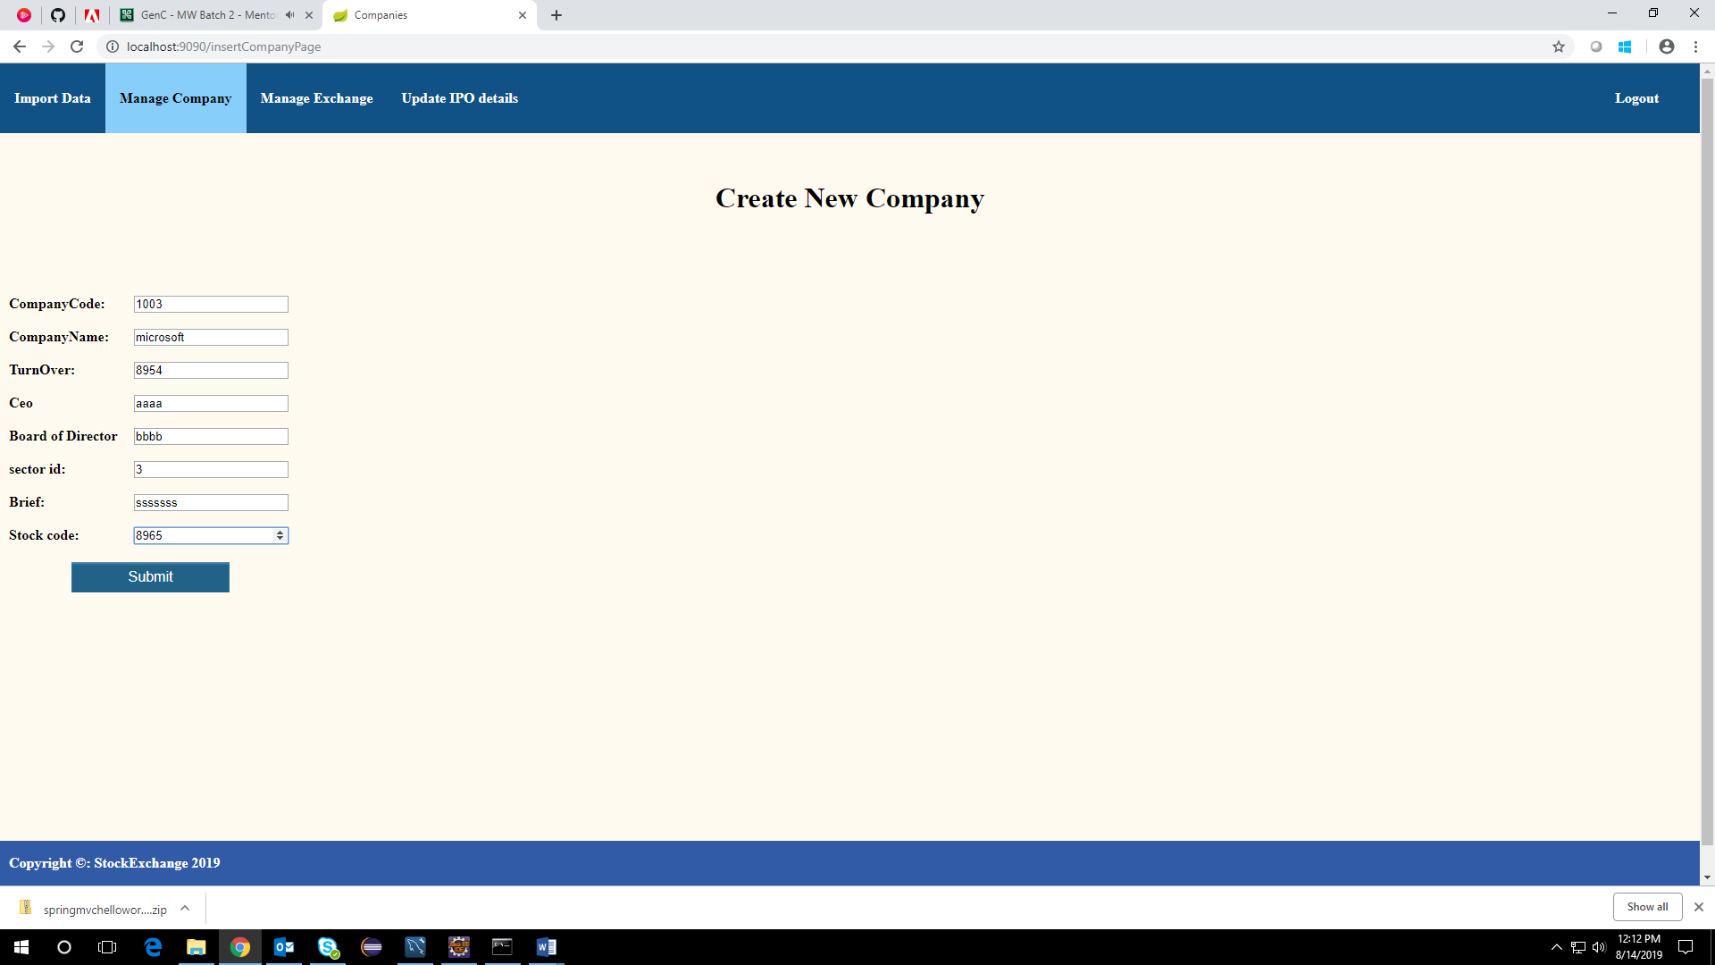

1. **Display the inserted record**

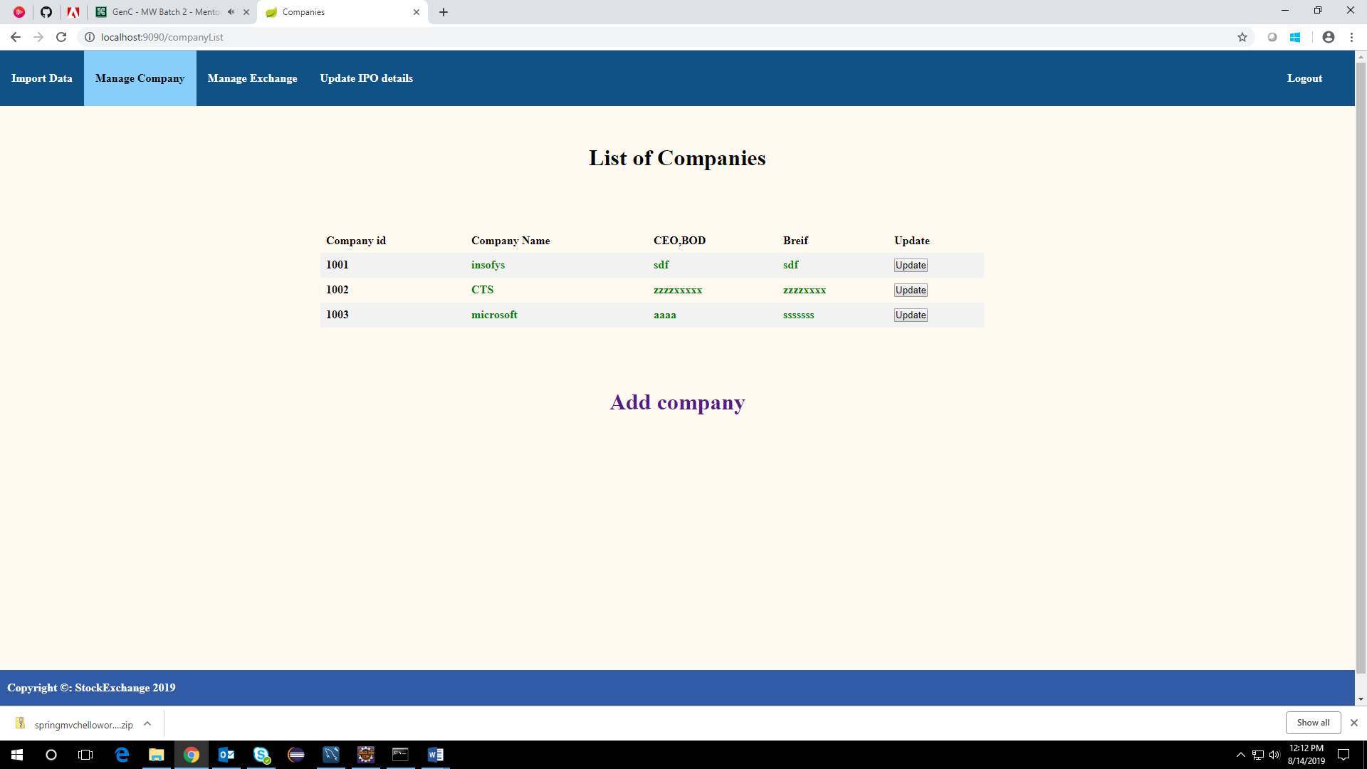

**CODE GITHUB LINK**

https://github.com/NAVEDHA98/StockMarketChart-Milestone2